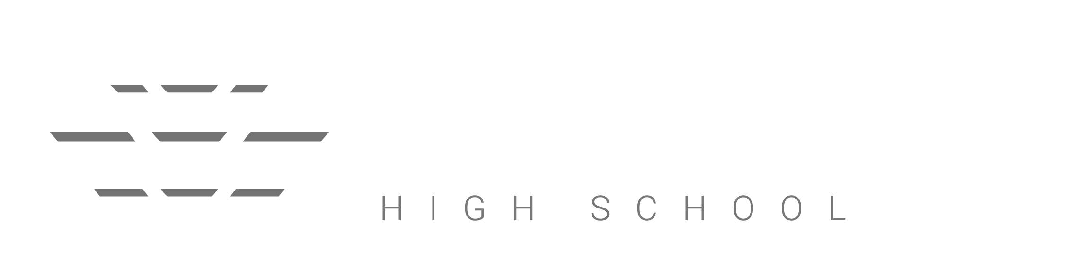

ClassCharts

Getting started – Student Accounts

Contents
What is Class Charts for students? 3
Logging in to Class Charts 4
Behaviour 5
Homework 6
Homework status categories 7
Keeping track of homework 8
Homework attachment submissions 9
Detentions 10
Attendance 11
Timetable 12
Classes 13
Reward Store 14
FAQs and troubleshooting 15

What is Class Charts for students?

Class Charts allows you to keep track of your achievements and behaviour, buy rewards from the Reward store, stay on top of your homework, keep track of scheduled detentions, view your timetable, check your attendance, create wellbeing submissions and view announcements from your school using the app on your IOS device or Android device.
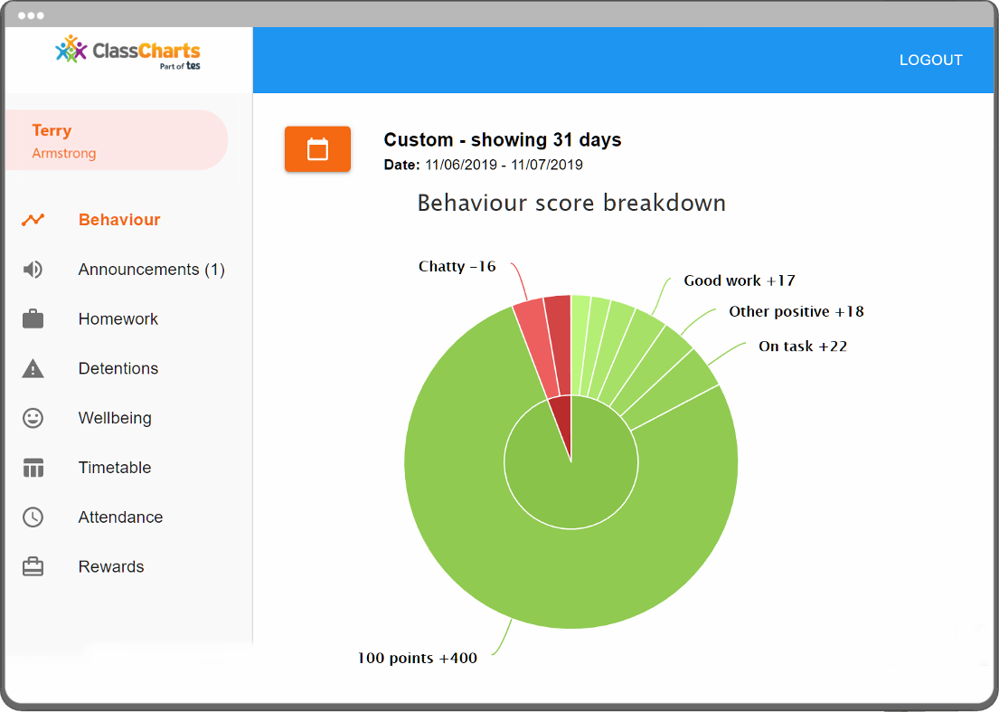
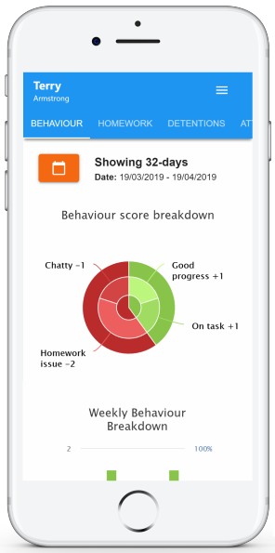
Class Charts for students can be accessed via our website, or by your iOS and Android apps. You can find the app at the appropriate app store. You can access the student website and links to the student app via your app store or login via the internet: https://www.classcharts.com/student/login

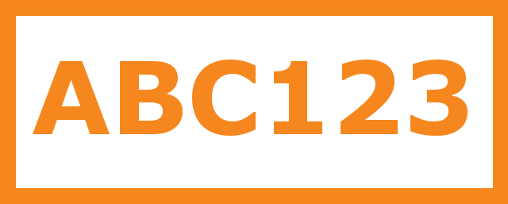
You should have received a Student code from your school, which will look similar to the example code shown on the right.

This code is used to log into your student account, which is covered on the next page

Logging in to Class Charts

Follow the steps below to access your student account.
If you are struggling to access this please contact your form tutor who will supply you with your unique code.

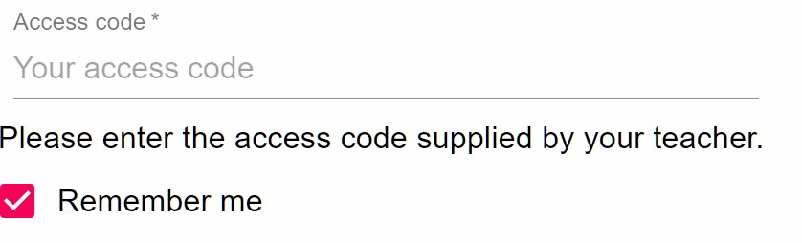
- Enter your school email address and password into the fields provided.

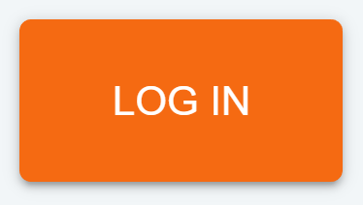
- Click on the Log in button.

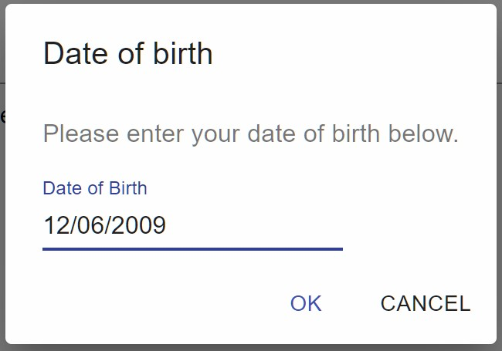
- Enter your date of birth if prompted and click on the OK button.

Behaviour

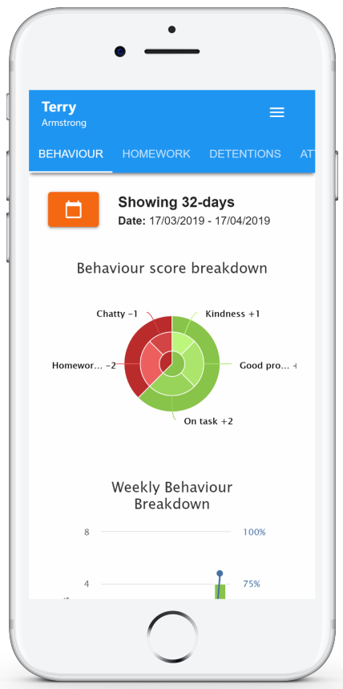
LHS has decided to share behaviour information, you will see the Behaviour tab in your account.

Selecting this tab will display your overall behaviour in the form of a pie chart and a bar graph.

By default, the displayed date range is 31 days . To view a different range of behaviour data, click on the Date button.

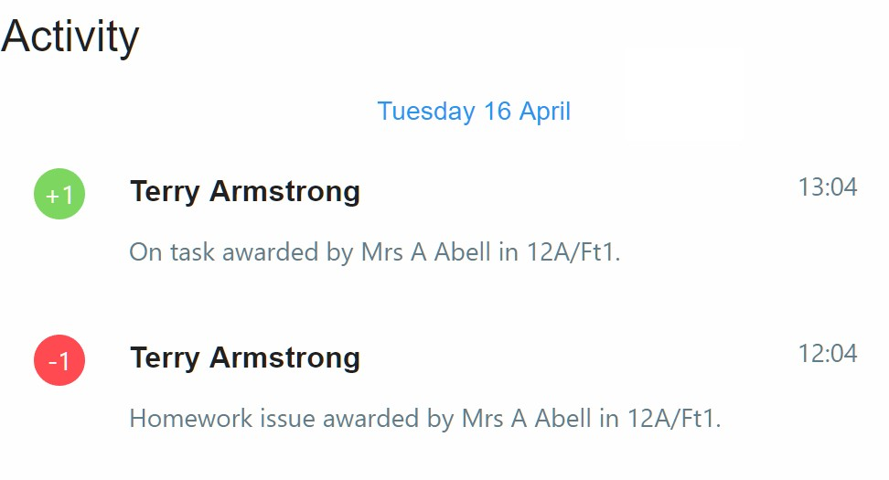
Below these graphs you will find a list of behaviour activity. These display the behaviour that was awarded, when it was awarded, who awarded the behaviour, the lesson the behaviour was awarded in, and how many points the award is worth.

The level of detail within each behaviour award depends on the settings that your school has enabled.

Homework

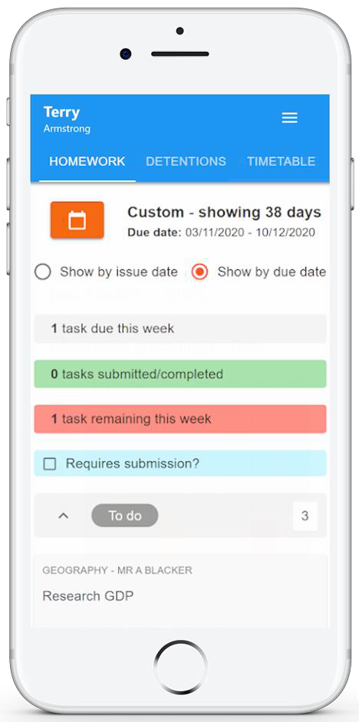
LHS has decided to share homework with students, you will see the Homework tab in your account.

Selecting this tab will display a list of the homework tasks which you have been given.

To change the date range for displayed homework tasks, click on the orange Date button.

To display tasks in the order they were set, click on the Issue Date button

To display tasks in the order they are expected to be handed in, click on the Due date button.

To mark a homework task as completed, view the homework task of your choice in more detail and tick the Completed? checkbox.

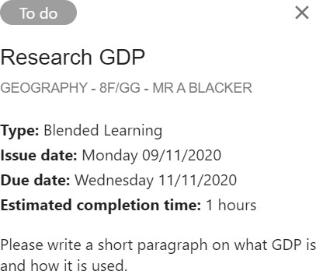
To view a homework task in more detail, click on the expand icon in the bottom right hand corner of the homework tile.

A popup will appear that contains the a description of the homework task, the estimated completion time and any links or attachments that may have been included.

Homework status categories

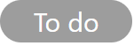
To-Do: These are homework tasks that you need to complete. Once you have completed them, tick the checkbox.

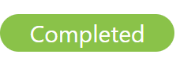
Completed: These are homework tasks that you have ticked as completed but have not been marked by your teacher.

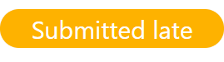
Late: These are homework tasks that have been handed in past the deadline.

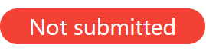
Not submitted: These are homework tasks that were not handed in on time.

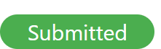
Submitted: These are homework tasks that have been handed in on time.

Keeping track of homework

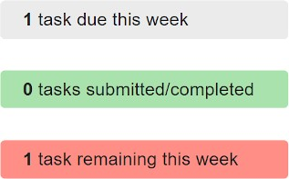
As you are assigned homework tasks, you may want track of how you are progressing for the current week.

The three banners above the homework status categories count the number of homework tasks that are due this week, how many of those tasks you have completed and how many tasks you still need to complete.

To only see homework tasks that
require an attachment submission, tick 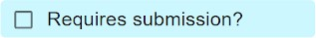
the checkbox labelled Requires submission.

If you are viewing the Homework tab via a desktop or laptop, expanding a homework status category will display a table overview of each homework task for the selected date range.

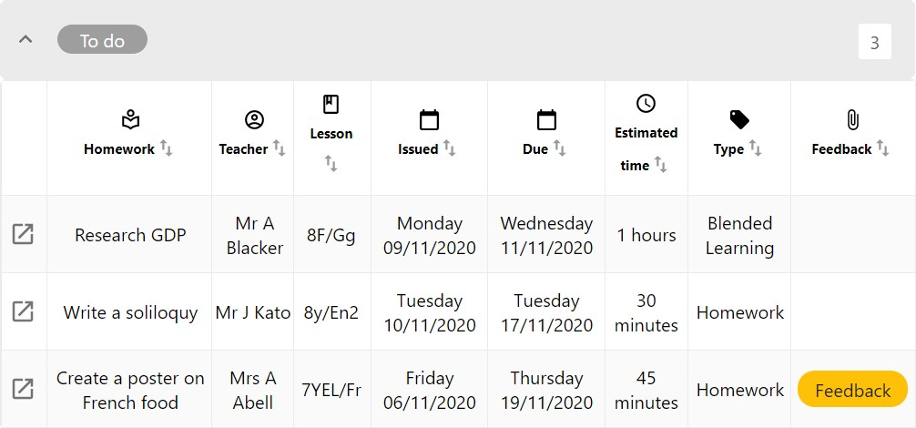

Homework attachment submissions

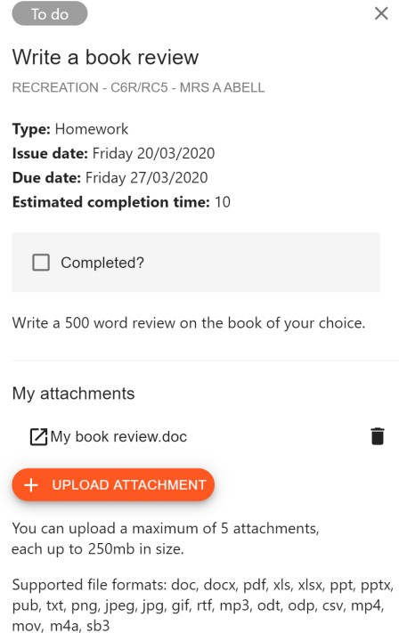
For certain homework tasks, you may be asked by your teacher to upload your work as an attachment.

When viewing a homework task in more detail, you will see the Upload attachment button if your teacher is expecting your work to be uploaded.

To submit a homework attachment, click on the Upload attachment button and select the files of your choice. Successfully uploaded files will then appear above the button.

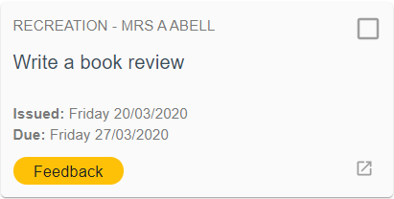
If your teacher leaves feedback on one of your homework attachments, you will see a Feedback icon appear on the associated homework task.

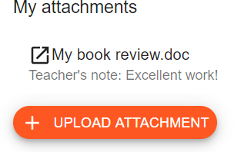
To view the feedback, click on the expand icon in the bottom right hand corner of the homework tile. Your teacher’s feedback will appear directly below your homework attachment.

Detentions

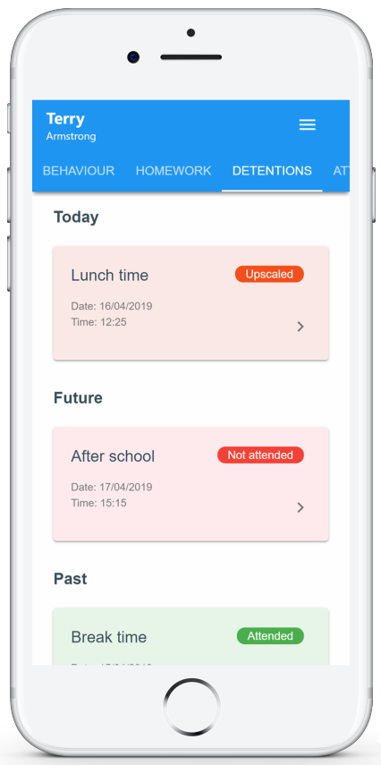
LHS has decided to share detention information with students, you will see the Detentions tab in your account.
Selecting this tab will display a list of
detentions which have been set for you.

Detentions fall under 4 categories: Attended, Not attended, Pending and Upscaled.
Attended: You have sat this detention.

Not attended: You have not sat this detention.

Pending: This detention has not been sat and has not been marked as Attended / Not attended by your teacher.

Upscaled: This detention has escalated into another type of detention.

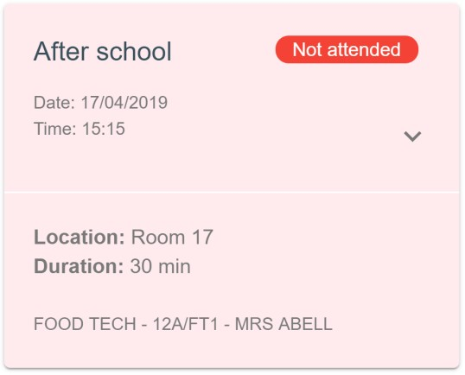
To view more information about a specific detention, click on the arrow icon.

This will bring up a popup that describes the detention, including the location for the detention, the awarding teacher and scheduling information.

Attendance

LHS has decided to share attendance information with students, you will see the Attendance tab in your account.

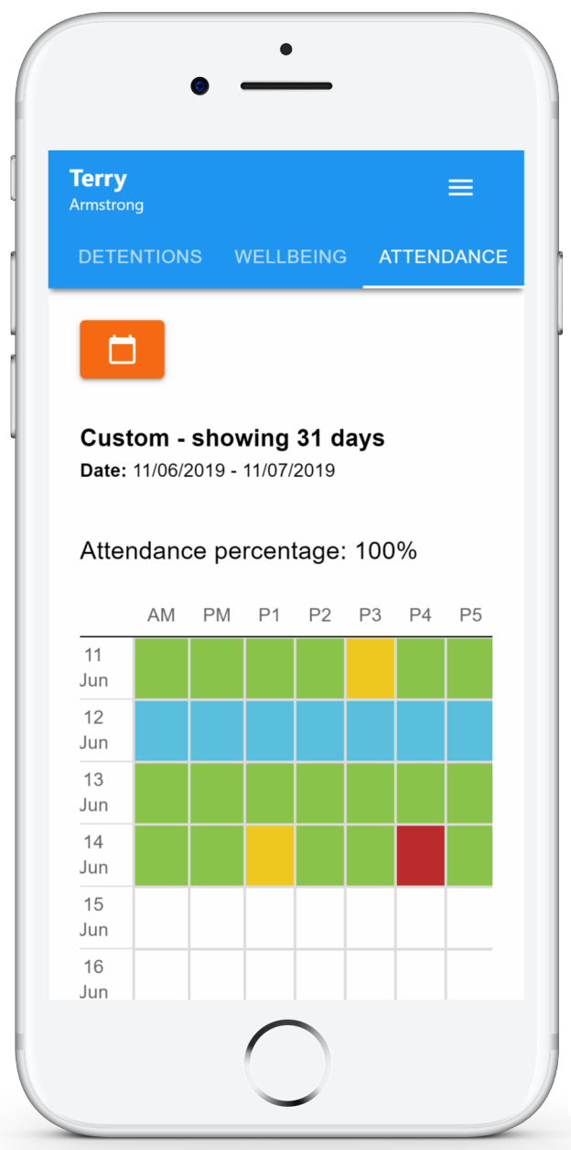
Selecting this tab will present your attendance data for the past 31 days.

To change the displayed timeframe of attendance records, click on the orange Date button and select the date range of your choice.

Attendance records fall under four categories: Present, Late, Authorised absence and Unauthorised absence.
Present: You attended the
lesson.

Late: You were late to the lesson.

Authorised absence: You did not attend the lesson, but had a valid reason for doing so.

Unauthorised absence: You did not attend the lesson and did not have a valid reason to do so.

Timetable

LHS has decided to share timetable data with students, you will see the Timetable tab in your account.

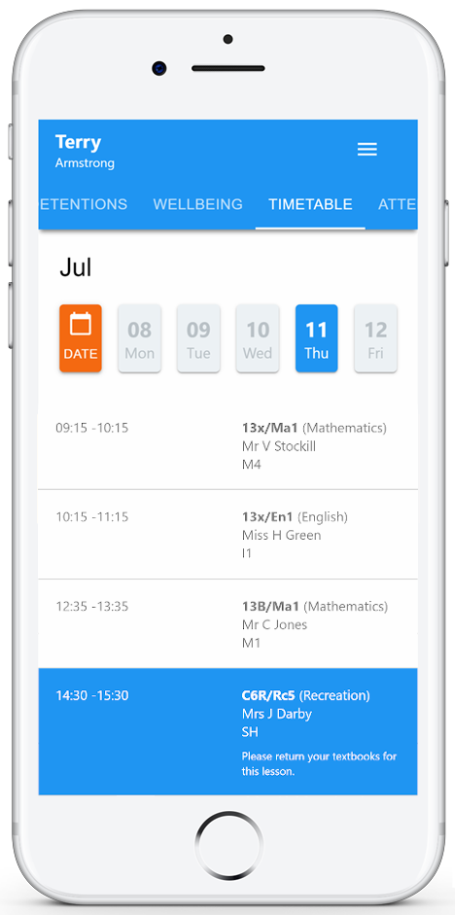
Selecting this tab will present you with your timetable for the current day. This includes the time for each lesson, the lesson name, the
teacher’s name, the room where the lesson will take place and the lesson subject. If your teacher has left timetable notes, you will also see them for the lesson in your timetable.

Your current lesson will be highlighted in blue, as shown on the right.

To view your timetable for another day of the week, click on one of the other displayed dates along the top of the timetable.

To change the displayed week, click on the orange Date button and select a date from the week of your choice.

Classes

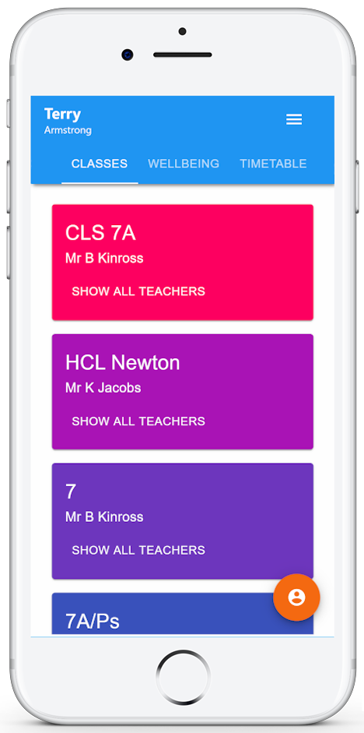
Selecting this tab will present you with a list of your classes. Each class tile will display the class name, the class teacher, the subject and the room the class takes place in (if applicable).

To view the full list of teachers for a specific class, click on the Show all teachers button for the class of your choice.

Reward Store

LHS has a reward store, you will see the Rewards tab in your account.

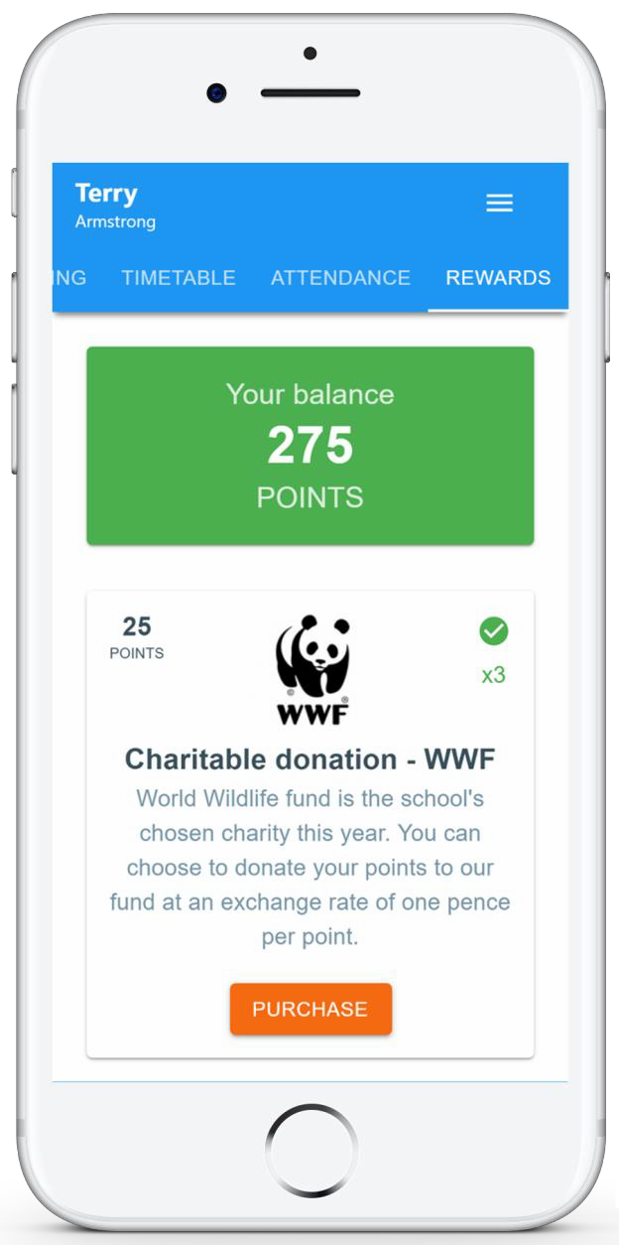
Selecting this tab will present you with the rewards that are available and how many points they cost.

The Balance number shows how many points you have available to spend.

To purchase a reward, simply click on the Purchase button below a reward.

If you have enough points, the cost will be taken away from your balance and the reward will be successfully purchased. All rewards are distributed on a Monday by the student leaders.

Please speak to Mrs Moffat or Miss Woods if you have any questions regarding the rewards shop.

FAQs and troubleshooting

“I don’t have a student code!”
Please contact your school and ask for a new student code.

“I’m not seeing !”

This quick start guide provides information on all of our modules. If you are not seeing a module mentioned in this guide, your school may not have decided to purchase / enable that module.

“I would like to know more about the Class Charts privacy policy“
- Your data is held securely in the UK.
- Your data is shared with us by the school and we will only use it for the purpose it is
shared for.
- We will not share your data with anyone.
For more detailed information please click here: https://www.edukey.co.uk/edukey-terms-conditions/

